Seminar Notifier

Project Proposal

By

Miss Nattakarn Promsorn 522115015

Department of Software Engineering

College of Arts, Media and Technology

Chiang Mai University

Project advisor

_________________________________

Mr. Kittitouch Suteeca

**Document History**

|  |  |  |  |  |  |  |
| --- | --- | --- | --- | --- | --- | --- |
| Document Name | Version | Status | Date | Viewable | Editable | Responsible |
| Document | | | | | | |
| Seminar Notifier_Proposal_0.1 | Seminar Notifier_Proposal_0.1  Added   * Abstract * Introduction and Background * Literature Review * Quality Standard * Project Plan | Draft | 29-12-2012 | KS, NP | NP | NP |
| Seminar Notifier_Proposal_0.2 | Seminar Notifier_Proposal_0.2  Updated   * Abstract * Introduction and Background * Literature Review * Quality Standard * Project Plan * Reference | Draft | 15-01-2013 | KS, NP | NP | NP |
| Seminar Notifier_Proposal_1.0 | Seminar Notifier_Proposal_1.0 | Approved | 31-01-2013 | KS, NP | NP | NP |

Document Designed by

Nattakarn Promsorn

31 January 2013

Document Approved by

Mr Kittitouch Suteeca

31 January 2013

**Abstract**

Seminar is a form or a kind of academic instruction at the academic institution or offered by a commercial or professional organization.[1] Seminar is a meeting requiring experts or lecturers that focus each time on some particular subject, in which attendees are sometimes requested to participate. So one of the problems of the seminar is that guests do not know the way to the seminar and they always end up calling the company’s call center or receptionist of the venue to ask for the instruction. For example, if this event has 100 guests, the call center may have to repeat the instruction over 100 times. This is the main problem for seminars that wastes time and human resources. The receptionist should better spend time on other things such as servicing guests at the counter. So I have decided to develop this application in order to help the receptionist or call center of the company and seminar’s guests with directions and to reduce misunderstandings each other and for the convenience. It also can save time and human resource of the company. This application can show the path to get the location of the event or seminar.

Table of Contents

TOC \t "heading 1, 1,heading 2, 2,heading 3, 3"\b _TOCRange

Chapter 1 | Introduction and Background PAGEREF _Toc \h 5

Chapter 2 | Literature Review PAGEREF _Toc1 \h 6

Business Review PAGEREF _Toc2 \h 6

Seminar in CRM & Cloud Consulting Company (CRM-C) PAGEREF _Toc3 \h 6

Business tools/software Review PAGEREF _Toc4 \h 7

Java PAGEREF _Toc5 \h 9

2. Google Maps API PAGEREF _Toc6 \h 10

4. Android OS PAGEREF _Toc7 \h 11

Development Tools Review PAGEREF _Toc8 \h 13

Chapter 3 | Quality Standard PAGEREF _Toc9 \h 15

ISO29110 for Very Small Entity (VSE) PAGEREF _Toc10 \h 15

Project Management process PAGEREF _Toc11 \h 15

Software Implementation process PAGEREF _Toc12 \h 16

Chapter 4 | Project Plan PAGEREF _Toc13 \h 16

Motivation PAGEREF _Toc14 \h 16

Aims and Objectives PAGEREF _Toc15 \h 16

Deliverables and Limits PAGEREF _Toc16 \h 17

Chapter 5 | Reference PAGEREF _Toc17 \h 20

# Chapter 1 | Introduction and Background

Nowadays seminar is quite important in our life. Seminar can occur with every job because an organization needs to improve service quality or help modernize their organization. In development, an organization is needed to invest in a variety side including investment finance, materials and technology. The important factor is an investment in human resources because employees are as a valuable resource in the organization. The organization should focus on development human resource by improving their skill and knowledge in order to increasing efficient about their jobs. Therefore, it helps the consequently to development and stability of the organization in the next step.

However, organizing a seminar may be difficult. One of the reasons is finding an appropriate location. For example, a seminar about Software Quality Assurance at CRM and Could Consulting company in Bangkok and if there is a problem with the location, or with the guests’ ability to travel to the location, communication is often very difficult. It is a responsibility of the organizers to keep the people involved informed with updates and changes, especially of time and locations. With any large event or organization, it may be very difficult to tell all the people involved that the organizers changed the location. Sometime, the seminar location is difficult to find or not famous that make almost of guests do not know the way to go to the seminar. They will call to receptionist or call center to ask the location of the seminar. The receptionist or call center must answer the same question to lots of guests that it is waste the valuable time of both guests and the receptionist.

Presently, almost people use smartphone for make their lives easier because the application on mobile is help the user’s live more convenient. Almost activities are done by using the application via the internet such as movie ticket booking and fight ticket booking. So I decided to develop the android application on mobile to help organizers easily show the guests the location of the seminar. This application can booking date and time of seminar in user’s calendar and also can remind the user about seminar upcoming.

# Chapter 2 | Literature Review

## Business Review

### Seminar in CRM & Cloud Consulting Company (CRM-C)



Figure 1.1 CRM and Cloud Consulting Company

CRM & Cloud Consulting Company is a consulting company and assists other business about customer relationship management.[2] This company focuses on working on cloud computing more than just IT solution. Nowadays the cloud computing is very popular because we can access the data on cloud computing everywhere just using the internet. A deep understanding of other issues, such as people and process, must be aligned with the system in order to realize the full potential of the Cloud. The company will serve for developing the customer relationship management system in the form of cloud computing and office collaboration suite tools. The company team comprise of experts from diverse fields with insights into local businesses. However, as advocates of cloud computing, this company is continuously expanding offerings to meet clients’ needs. CRM & Cloud Consulting Company separated to two sides which are business and charity. In the business side will focus on customer relationship management. The charity side is collaborating with Google Company about Google application for education in Thailand. The company always has seminar about training user many times in each month. Sometime, the seminar location is hard to find, and the guests do not know the way to go to the company or seminar location and then they always call to office call center or receptionist for ask the seminar location. The receptionist may be bored to answer the same question. This problem will waste their valuable time both guests and the receptionist. Therefore, this application will help resolve this problem.

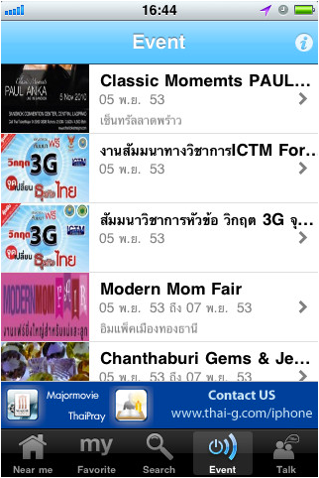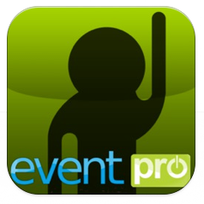

## Business tools/software Review

1. **Eventpro**

The Eventpro is an iPhone application that helps users to find or search the event in Thailand that users interesting in or nearby user. [3] So users will not miss the favorite events and also can share information the event to other by email.

* Display all events and events detail.
* Find event from categories such as animal, plant, business, education, government, entertainment, fair, family, healthy, fashion, home, furniture, sport, technology, innovation, travel, festival, night, concert and other section.
* Find event in the nearest location from GPS position.
* Search event with keyword and category.

Pros:

* It easily to know the event in Thailand and around user.
* Users also can search event by categories.
* It can show the location of each event.

Cons:

* This application just shows the location, but it does not show the route of the event.
* Cannot book event to calendar.
* Cannot remind the user.

**Technology Review**

### Java

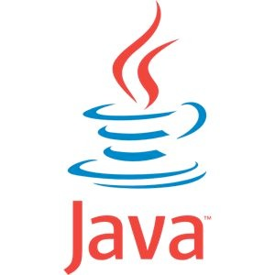

Figure 1.4 Java Programming Language

Java is one of the most popular programming languages in the world, especially for web based client-server applications.[4] Java is a programming language designed for ease of portability, without a reliance on set computer architecture. The code compiles first into a byte code that then runs within a Java Runtime Environment, which is not dependent on hardware. This allows for Java’s exceptional portability. Most programs can be run on any operating system, and any hardware. Java was developed with syntax relatively similar to C and C+ on a high level, but at a lower level there are not many similarities.

**Alternative Technology**

Objective-C language is a simple computer language designed to enable sophisticated object-oriented programming. Objective-C is defined as a small but powerful set of extensions to the standard ANSI C language. Its additions to C are mostly based on Smalltalk, one of the first object-oriented programming languages. Objective-C is designed to give C full object-oriented programming capabilities, and to do so in a simple and straightforward way.

C# is a multi-paradigm programming language encompassing strong typing, imperative, declarative, functional, generic, object-oriented (class-based), and component-oriented programming disciplines. It was developed by Microsoft within its .NET initiative and later approved as a standard by Ecma (ECMA-334) and ISO (ISO/IEC 23270:2006). C# is one of the programming languages designed for the Common Language Infrastructure.

**The selection of this technology**

JAVA is the basic computer language for creating and developing an android application. So we think JAVA is suitable for our project.

### 2. Google Maps API

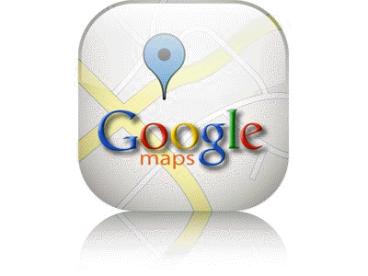

Figure 1.5 Google Maps API

Google Maps API is the application programming interface developed by Google and launched in 2005. The API is designed to facilitate integration of Google Maps into an application, especially a website.[5] Currently over 350,000 websites employ some version of Google maps, thanks to Google Maps API.

**Alternative Technology**

Bing Maps Platform (previously Microsoft Virtual Earth) is a geospatial mapping platform produced by Microsoft. It allows developers to create applications that layer location-relevant data on top of licensed map imagery. The imagery includes samples taken by satellite sensors, aerial cameras, Street side imagery, 3D city models and terrain.

**The selection of this technology**

Google Map APIs have many sample code on the internet. Google provides completely code for developers. We can get the complete code from Google and adapt to our project. It can help us to self-time to create new code about map.

1. **Jason**



Figure 1.6 Jason

JSON (JavaScript Object Notation) is a lightweight data-interchange format. It is easy for humans to read and write.[6] It is easy for machines to parse and generate. It is based on a subset of the JavaScript Programing Language, Standard ECMA-262 3rd Edition - December 1999. JSON is a text format that is completely language independent but uses conventions that are familiar to programmers of the C-family of languages, including C, C++, C#, Java, JavaScript, Perl, Python, and many others. These properties make JSON an ideal data-interchange language.

**Alternative Technology**

Extensible Markup Language (XML) is a markup language that defines a set of rules for encoding documents in a format that is both human-readable and machine-readable. It is defined in the XML 1.0 Specification produced by the W2C, and several other related specifications, all gratis open standards.

**The selection of this technology**

XML is simpler than SGML, but JSON is much simpler than XML. JSON has a much smaller grammar and maps more directly onto the data structures used in modern programming languages. And JSON is not extensible because it does not need to be. JSON is not a document markup language, so it is not necessary to define new tags or attributes to represent data in it.

### 4. Android OS

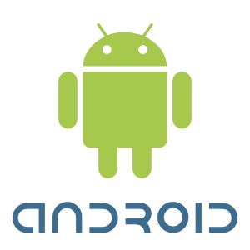

Figure 1.7 Andriod OS

Android OS is an operating system which bases on Linux for mobile devices such as smart phone and tablet. This technology includes an operating system, software, and applications. Android is maintained and developed by the Android Open Source Project (AOSP). Android technology is based on JAVA software applications that require the use of a special software development kit (SDK) to create the applications.[7]

**Alternative Technology**

iOS from Apple Inc.'s mobile operating system. Originally developed for the iPhone, it has since been extended to support other Apple devices such as the iPod Touch, iPad, and Apple TV. Unlike Windows CE (Mobile and Phone) and Android, Apple does not license iOS for installation on non-Apple hardware.

**The selection of this technology**

Android OS is the open source. This application from Android developer can test on Mobile, but iOS must upload to Appstore then this application can run on mobile. The platform evolved as the developer community work together for building the mobile application. It will have more references and tutorials. It can help when we have the problem, and Android application use JAVA language to base on developed application.

**5. Google Calendar**



Figure 1.8 Google Calendar

Google Calendar is a free time-management web application offered by Google. It became available on April 13, 2006, and exited the beta stage in July 2009. Users are required to have a Google Account in order to use the software.[8]

**Alternative of this technology**-

**The selection of this technology**

Google Calendar is a free Internet calendar that lets you keep track of your own events and share your calendars with others. It's the ideal tool for managing personal and professional schedules. It is both simple to use and very powerful.

## Development Tools Review

1. **SQLite**



Figure 1.9 SQLite

SQLite is a small but powerful database engine that takes virtually no configuration to set up and lives in a single file. It is extremely handy for quick and easy databases. We have actually talked about SQLite here before at Switch On The Code a couple of times. For a thorough understanding of how to interact with SQLite

**Alternative Tool**

-

**The selection of this tool**

SQLite is interesting because it is an open source. It has a lot of tutorials to guide us when we have problem. And apple gave application developers the ability to use SQLite inside their applications.

1. **Eclipse With ADT Plug- in**



Figure 1.10 Eclipse With ADT Plug-in

Android Development Tools (ADT) is a plug-in for the Eclipse IDE that is designed to give you a powerful, integrated environment in which to build Android applications. ADT extends the capabilities of Eclipse to let you quickly set up new Android projects, create an application UI, add components based on the Android Framework API, debug your applications using the Android SDK tools, and even export signed (or unsigned) APKs in order to distribute your application. Developing in Eclipse with ADT is highly recommended and is the fastest way to get started. With the guided project setup it provides, as well as tools integration, custom XML editors, and debug output pane, ADT gives you an incredible boost in developing Android applications [9].

**Alternative Tool**

NetBeans IDE is written in Java and can run on Windows, Mac OS, Linux, Solaris and other platforms supporting a compatible JVM. A pre-existing JVM or a JDK is not required.

**The selection of this tool**

Eclipse with ADT Plug-in is SDK to develop android application. It provides the tools and APIs (Application Program Interface) necessary to begin developing android applications on android platform using JAVA programming language such as Android Emulator. The developer can use it to show results when we compile an application for test application before port to the android device.

# Chapter 3 | Quality Standard

## ISO29110 for Very Small Entity (VSE)

The ISO 29110 has been concerned with the process that improves the system and is the universal 2 main processes. 1. Project Management and 2. Software Implementation, it’s composed with the sub-process. 2 processes designed to suite for VSE (very small entity) so it suitable to use immediately by define scope of process to suitable for VSE so it won’t make the problem to organization.

### Project Management process

The purpose of project management are to establish and carry out in a systematic way the tasks of the software implementation project, which allows complying with the project’s objectives in the expected quality, time and costs. There are 4 activities following these:

1. Project Planning

2. Project Plan Execution

3. Project Assessment and Control

4. Project Closure

### Software Implementation process

The purpose of software implementation process is the systematic performance of the analysis, design, construction, integration and tests activities for new or modified software products according to the specified requirements. There are 6 activities following these:

1. Software Implement Initiation

2. Software Requirement Analysis

3. Software Architectural and Detail Design

4. Software Construction

5. Software Integration and Tests

6. Product Delivery

# Chapter 4 | Project Plan

## Motivation

One of the big problem is guests do not know the route to go there. They always call the receptionist of the hotel and the company which is making the seminar. The companies’ employee should spend time on working more than answer the same questions. Guests do not know the events or the seminars are organized now.

This application can help guests, and the event organizer or the host to reduce misunderstanding about the route. It can show the location and the route to go there. It also can show the available seminar. Then it will reduce misunderstanding from guests.

### Aims and Objectives

**Aims**

* To help guests to know the route to go seminar.
* To reduce misunderstand each other’s between guests and receptionist of talking on the phone.
* To show the available seminars.

**Objectives**

* To develop system which is Android application that provide accessibility and usability for guests and other who interesting in seminar.
* The application can show the route to go to seminar and available seminar. Then guests will know the route to go there.

### Deliverables and Limits

**Deliverables**

The completed Seminar Notifier application must be implemented on the following features:

**Progress I**

* Design User Interface (UI) on mobile application
* Feature 1: The application can show all available seminar list view and seminar detail that including seminar name, date, time, description, seminar location and route of seminar location.
* Feature 2: Users can add interested seminars and the application can show interested seminar list, expert or lecturer name.
* Feature 3: The application has registration function in order to record user information to database.
* Feature 4: The application has login function in order to allow user can access the system.

**Progress II**

* Feature 5: The application can booking date and time in user’s calendar with Google 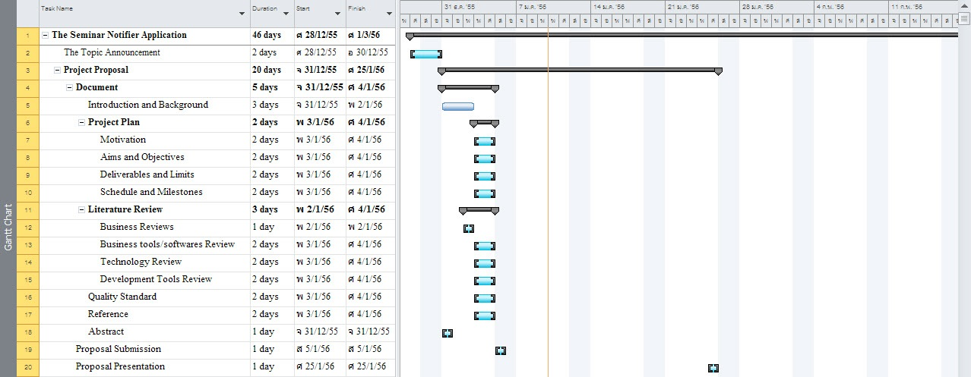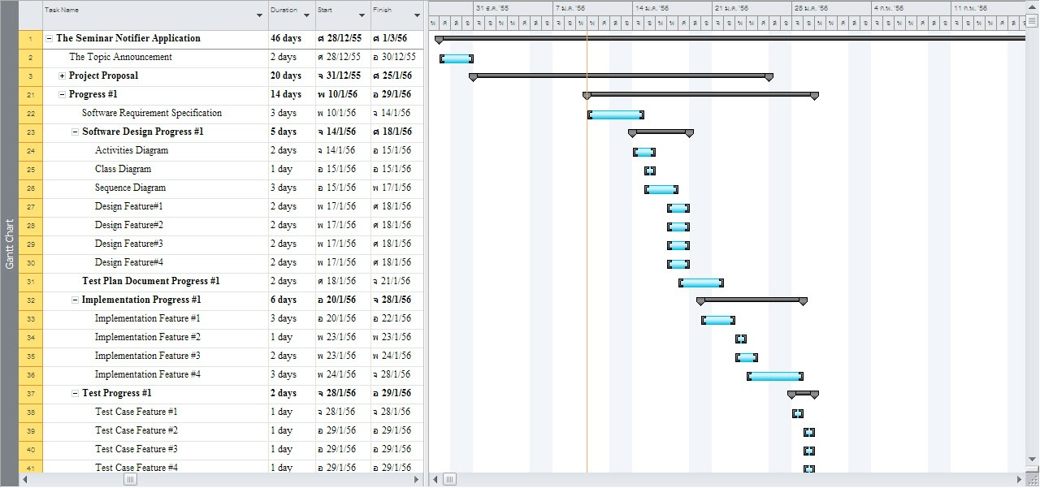calendar application. The user can view seminar in each day.
* Feature 6: The application can notify user about the upcoming seminar that user interested in via Google calendar.
* All document and application ready launch.

**Limits**

* The application can only run on Android OS version 2.3 or higher.
* The application need to connect with the internet and can access the Google map function.

**Schedule & Milestones**

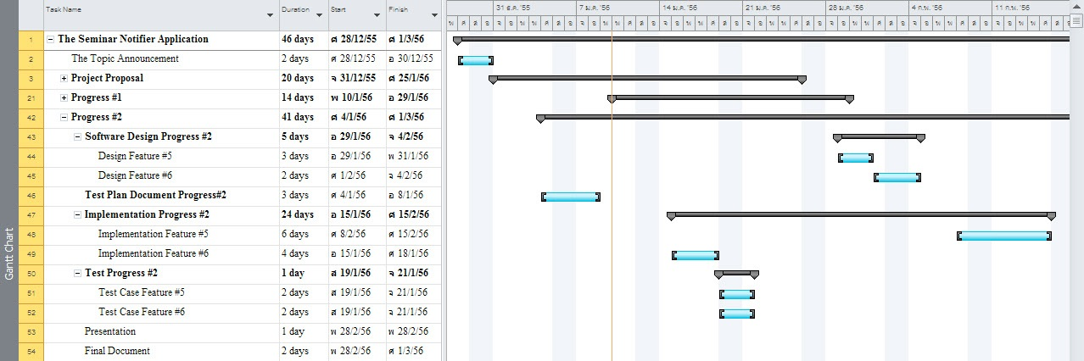

Figure 1.13 Progress 2 Milestone

# Chapter 5 | Reference

[1] Wikipedia. (2012). *Seminar*. 2012, from

<http://en.wikipedia.org/wiki/Seminar>

[2] CRM and Cloud Consulting. (2012). *CRM and Cloud Consulting.*2012, from

<http://www.crm-c.com>

[3] iTunes Preview. (2012). *Eventpro*. 2012, from

<https://itunes.apple.com/us/app/eventpro/id404705218?mt=8>

[4] Wikipedia. (2012). *Java (Programming Language)*. 2012, from

<http://en.wikipedia.org/wiki/Java_(programming_language>)

[5] Wikipedia. (2012). *Google Maps*. 2012, from

<http://en.wikipedia.org/wiki/Google_Maps>

[6] JSON. (2012). *JSON*. 2012, from

<http://www.json.org>

[7] Wikipedia. (2012). *Android (Operating System)*. 2012, from

<http://en.wikipedia.org/wiki/Android_(operating_system>)

[8] Wikipedia. (2012). *Google Calendar*. 2012, from

<http://en.wikipedia.org/wiki/Google_Calendar>

[9] Android Developers. (2012). *ADT Plugin*. 2012, from

<http://developer.android.com/tools/sdk/eclipse-adt.html>

used the concept of "Play and Lean". In the form of quest game, it makes this application has differed from other application in the market. User can download new quests from internet, install on these applications and run to play the game. Quest as same as the rally game, user will receive information about the condition to clear the game. The condition to clear the quest is traveling along many tourist attractions in Thailand that relate to that quest and check-in. Example is Kru bar Sri vi chai Quest". User can complete the quest by going to three difference places are Wat Phra that Doi Keung, Wat Suan Dok and Wat Phra That Doi Suthep in Chiang Mai which all related in Kru bar Sri vi chai' history. This application will give history, relationship and how importance to the users in the same time. User can download and update the new quests to join the new adventure while traveling in Thailand. Users will feel like playing the rally game. User will become part of the adventure not receive only information. User will feel exciting and enjoy while traveling to clear the quest.

This mobile application will perform the tour trips and deliver to the users as the game quest. The system will manage the mission before deliver to the users. Including with the time that users will use to complete the quest with more efficiency, the direction from one place to another place in that quest, the relation between the places and how to relate with the main history and the other information that users need to know. Such as the traveling guild information, nearest hotel, local restaurant and shopping mall, souvenir stores and the market place. Todays the technology on Mobile Phone, Internet connection, GPS (Global Positioning System), Geo Tracking and Social Network had become more advanced and grow quickly. Building mobile application is the way to connect and support users quickly and easily.

Therefore, the integration of quest game with new mobile technology is powerful systems along with well-designed and necessary tools that possibly facilitate the mobile traveling application to users. Especially, the mobile application is the main factors to promote in-house tourism in Thailand. Moreover, mobile application is flexible to extend and customize to meet a users requirement and easy to satisfy on their desire.